Sustainability in the Textile Industry – Discussion at the Student College of the Research Institute for the Integrity of Creation of PPKE

DOMESTiC NEWS – 10. December 2024, Tuesday | 17:35

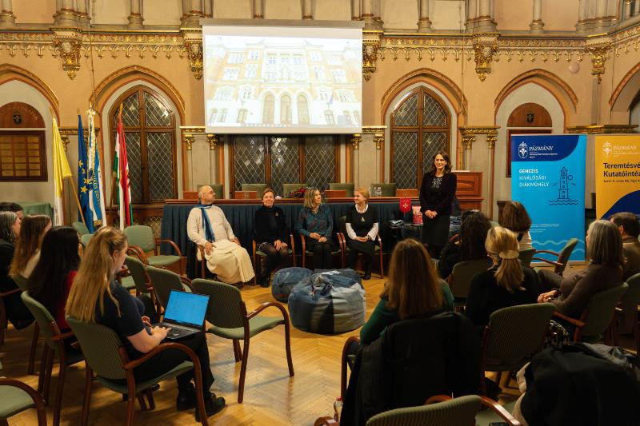 3

During Advent, many people take charitable action and reach out to the poorest. Hearing the pleas of the poor is far more than charity. With this thought in mind, on 4 December the GENEZIS Student College of Excellence of the Research Institute for the Integrity of Creation (TVKI) of the St. Pope John Paul II Research Centre of the Pázmány Péter Catholic University (PPCU) organised its second St. Martin's Day in Budapest.
The topic of the highly successful roundtable discussion was the connection between the catching up of regions that lag behind and the textile industry in the context of sustainability and creation protection.
The fashion industry has been a cause of environmental and social disasters over the past twenty years, becoming the fourth most polluting manufacturing sector on Earth. Clothing production, which involves the emission of pollutants, is also exploitative in terms of natural resources. “The social and societal situation of the workers involved in the production is also inhumane and is a form of modern-day exploitation," emphasized Dóra Farkas (PPKE Doctoral School of Law and Political Sciences).
Seeing the immeasurable pollution of the luxury textile industry, Szilvia Daskó Györgyné Szabó (dressmaker’s integrator, Hungarian Charity Service of the Order of Malta) embarked on the construction of the ReFarmerBank in Tarpa. In their work in the field of social inclusion, the Hungarian Charity Service of the Order of Malta have always considered it a fundamental goal to ensure that their useful work serves a good purpose: they strive to restore the dignity of those living on the margins of society.

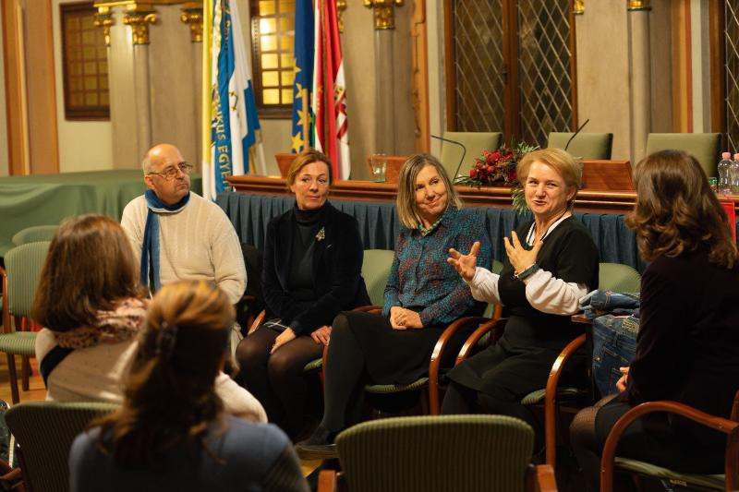
In Hungary, a good practice has also been implemented in the Krishna Valley in Somogyvámos, where textile production is now carried out in such a way that the principles of sustainability are observed throughout the entire work process, from the cultivation of the plants to the sewing of the finished garment, i.e. throughout the entire life cycle of the garment – in other words, the approach is one of creation protection. “Without religious conviction, this would not be possible," said Péter Németh, President of the Eco-Valley Foundation.
The speakers agreed that small communities have a sustaining power. Revitalising isolated regions and, at the same time, shaping environmental awareness brings to the surface many difficulties that are rarely talked about. Working in the dressmaker’s shop run by the Hungarian Charity Service of the Order of Malta in Tarpa means survival for many Roma women living in difficult circumstances – and through them, for their families. “Being able to escape from the overwhelming social and health-related difficulties of family life for a longer or shorter period of time and doing creative work gives strength even in the midst of the greatest hopelessness,” summarized textile artist and designer Betty Káli.

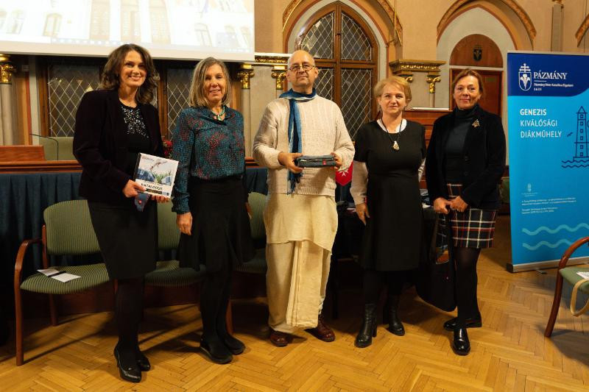
Made from used jeans - recycled is the trendy word - their products, aimed at younger people, are extremely popular. Pencil holders and bags, bean bags find their way to the younger generation. In the dressmaker’s shop of the Charity Service of the Order of Malta, the conservation approach is put into practice through excellent design work that produces products from recycled, natural materials, the lifespan of which exceeds that of the products offered by multinationals.
Their activity stretches far beyond job creation, as they also “get involved” in the social situation of each employee, and this requires extraordinary preparedness and flexibility. In recent months, the PPKE JÁK Caritas, a community organizing charitable activities, has been collecting used jeans for the dressmaker’s shop, which were handed over to ReFarmerBank representatives on the spot by the community, represented by Mátyás Hrubi, a student of the PPKE JÁK.
The participants of the roundtable discussion were convened and the program was moderated by Ágnes Tahyné Kovács (PPKE JÁK, TVKI), head of the GENEZIS Student College of Excellence.
Written by: Ágnes Tahyné Kovács (PPKE JÁK TVKI)
Source and photos: PPKE
Magyar Kurír

